Weather Unit Study Guide
Layers of the Atmosphere:
- Describe the composition of Earth’s atmosphere. (Include the percentages of gases.)
78% nitrogen, 21% oxygen, 1% other (argon, water vapor, and carbon dioxide)
- Name the 5 layers in order from lowest to highest altitude.
Troposphere, Stratosphere, Mesosphere, Thermosphere, Exosphere
- How does the temperature differ between the layers?
As altitude increases, temperature in the: Troposphere decreases,
Stratosphere increases,
Mesosphere decreases,
Thermosphere increases,
Exosphere decreases
- How does the air pressure differ from layer to layer?
Air pressure decreases as altitude increases.
- What is the ozone layer and where is it located?
The ozone layer is a protective layer found in the Stratosphere that blocks harmful Ultra-Violet light.
Water Cycle:
- List the seven steps of the water cycle and define each step. ***FOCUS ON THE FIRST 6***
Sun=Energy Source (evaporates the water)
Precipitation: rain, sleet, snow, or hail that falls to the ground
Evaporation: when water is moved from the Earth into the air
Condensation: when water vapor changes from a gas to a liquid stat as it is cooled
Runoff: water being moved from Earth’s surface to oceans
Transpiration: plants lose water out of their leaves and it evaporates
Groundwater: when water from precipitation soaks into the Earth
Accumulation: precipitation collects in large bodies of water
- Define relative humidity. How does temperature of the air effect how much water vapor it can hold?
The amount of moisture in the air compared to how much moisture it could hold at a particular temperature. The warmer the temperature the more water vapor air can hold.
Air Masses and Fronts:
- What is an air mass?
A large body of air with similar temperature and moisture content.
- List the 4 types of air masses and the characteristics of each.
Maritime Tropical (mT): humid and warm
Maritime Polar (mP): humid and cold
Continental Tropical (cT): dry and warm
Continental Polar (cP): dry and cold
- What is a front?
A boundary between different air masses.
- What are the 4 types of fronts and how do they form?
Warm Front: warm air mass slowly moves over cold, denser air
Cold Front: cold air mass violently crashes under a warm air mass
Stationary Front: cold air mass meets a warm air mass and remains separate
Occluded Front: warm air mass gets caught between two cold air masses
Severe Weather:
- How are hurricanes formed?
Hurricanes form over warm water in low pressure systems
- How are tornados formed?
Tornados form over land in an unstable atmosphere
Forecasting:
- Explain the differences between weather and climate.
Weather: conditions of a certain area over a short period of time
Climate: average conditions of an area over a long or extended period of time
- List the technologies used to study weather.
Barometer: measures air pressure
Thermometer: measures temperature
Anemometer: measures wind speed
Wind sock/vane: measures wind direction
Doppler radar, computers, hygrometers/psychrometers, weather balloons, and satellites
- What kind of weather is associated with each of the four fronts? Draw the symbols used to represent each front on a weather map.
  - Warm Front: gentle rain, followed by clear/warm temperatures

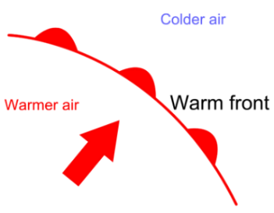

  - Cold Front: thunderstorms, heavy rain/snow, followed by cool temperatures

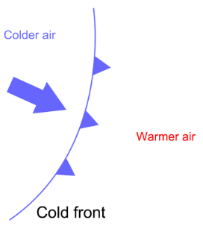

  - Stationary Front: cloudy, wet weather
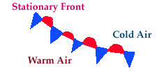

  - Occluded Front: cool temperatures with large amounts of rain and snow

- How are low pressure systems different than high pressure systems?
High pressure systems bring clear, calm weather (happy weather)
Low pressure systems bring clouds and stormy weather (lousy weather)

